TimeTrackingBackend Instructions to run the database code first, using postman, and unit test.

1. Open TimeTrackingBackEnd -> open Package Manager Console
2. Type “add-migration migration_name”
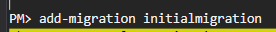

3. Type update-database. The database will be created in your local. Note(Database used is MS Sql).
4. Check database in you local.
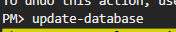

Unit Testing:
I used Xunit unit test. All test have passed based on the actual data that is inputed in the database.
Please refer below data for unit test purposes. You can execute this for unit test purposes.
INSERT INTO [dbo].[Employees] VALUES('Ariann28', '2020-03-30 09:00:00.0000000', '2020-03-30 06:00:00.0000000', 1)
INSERT INTO [dbo].[Employees] VALUES('AriannJr', '2020-03-30 09:00:00.0000000', '2020-03-30 06:00:00.0000000', 1)

Note: You can also try testing it in postman, just be sure to retrieve first the JWT token and copy it to the Authorization type: “Bearer Token” to access the endpoints.
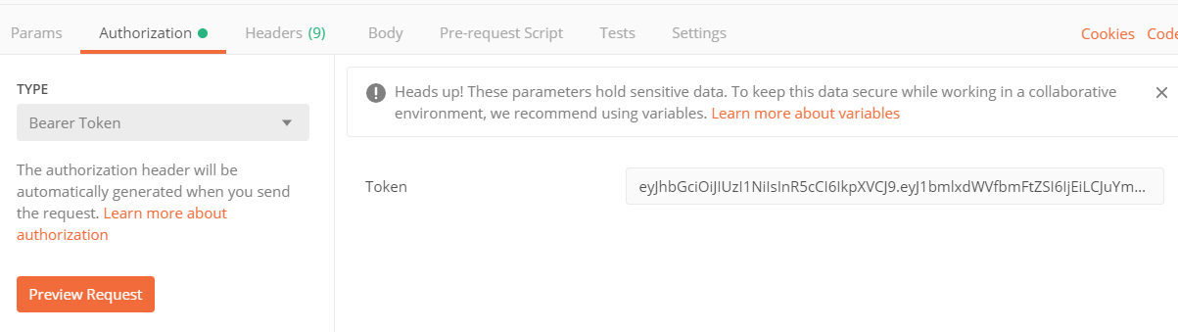

This is the final result of unit test
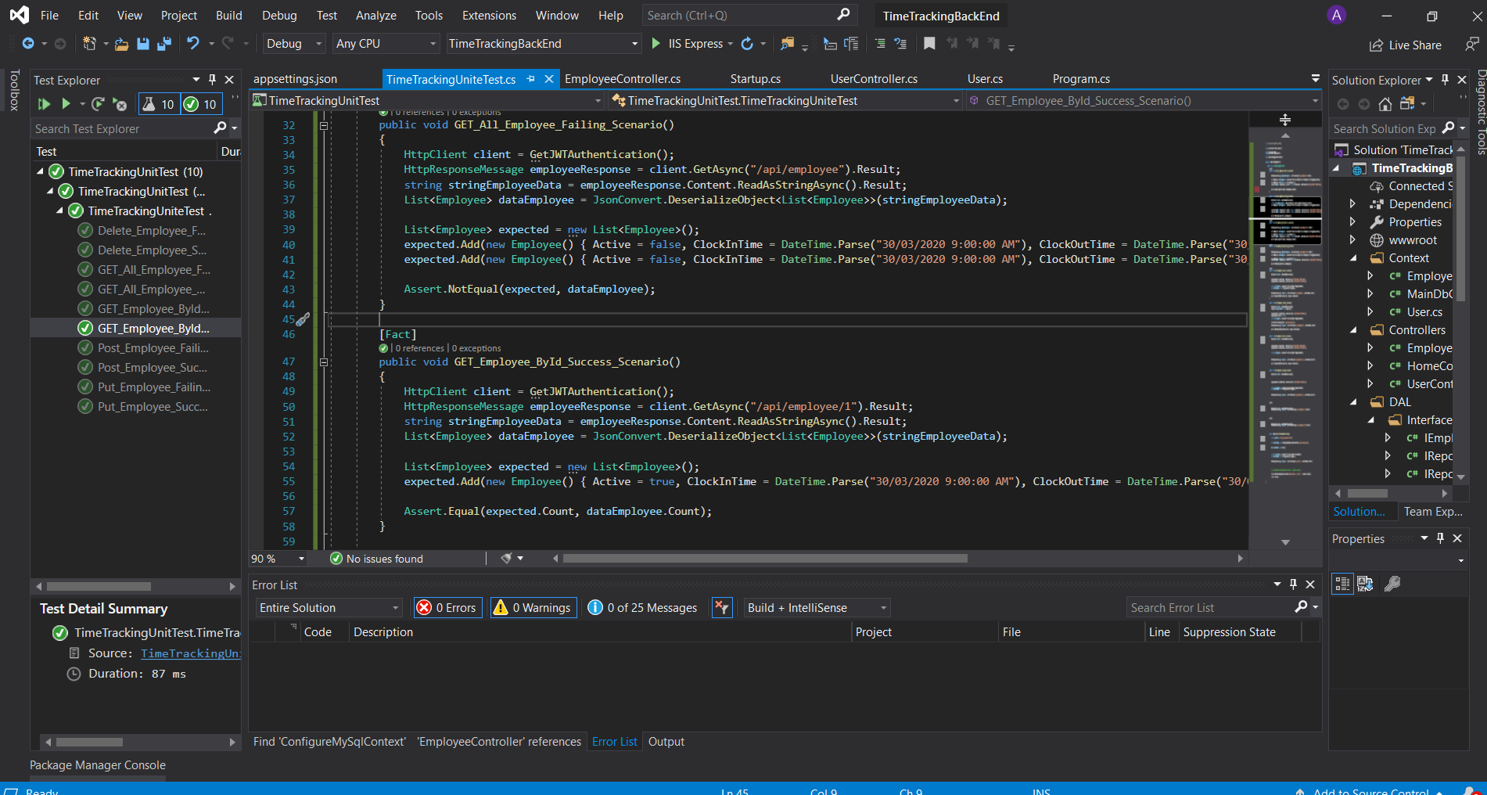

TimeTrackingFronEnd Instructions

Note: Please run both solution (backend and front end solutions)

On the backend side
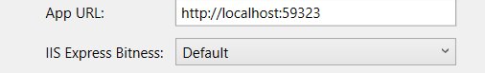

On the fronend side services
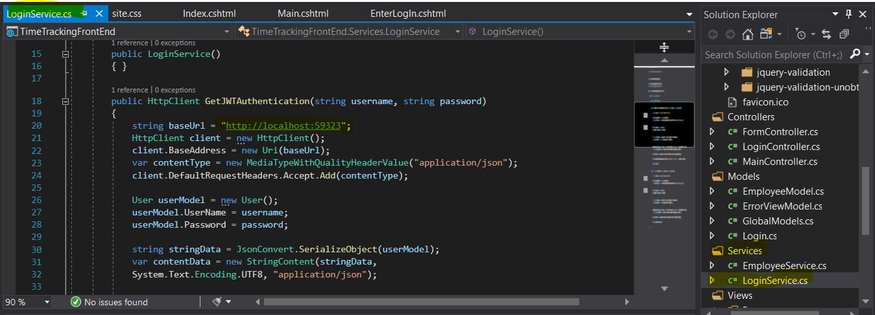

LogIn Instructions
1. Whenever you run the application you can login using the “hardcoded” credential below.
Username: test
Password: test

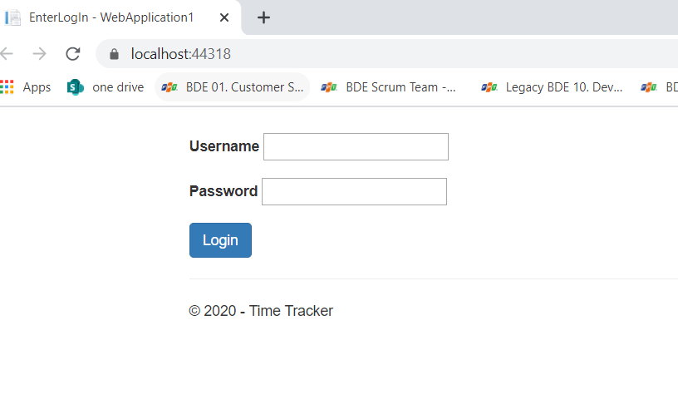

sample main table and form table

